**Second Year Computing**

**Web Development and Practical Databases**

**CSS Exercises**

**Lab Sheet 1**

**To be completed Monday 9/11/2020**

**Exercise 1**

Using **internal style sheets**, define your own styles for the h1, h2, …, h6 tags, and create a document with six heading levels that use the newly defined header styles.

Change the font sizes, font styles, font sizes (use px, percentages and ems), text colour, background colour etc.

Try lots of different combinations to see the effects of all the different options.

Below is just a sample of what some of the effects might be.

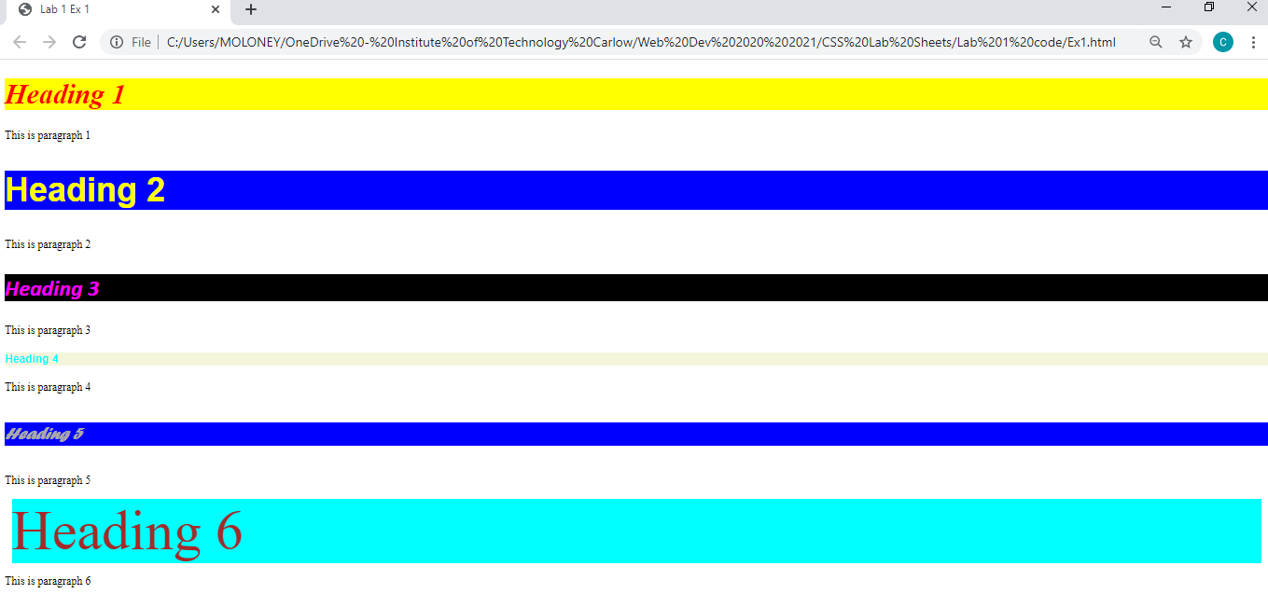

*Save your exercise files on M/WebDev/CSS Exercises/lab 1/ E1.html*

**Exercise 2**

Using **internal style sheets**, define three different paragraph **class** styles, p1, p2, and p3 that meet the following requirements, and create a document to see the effect of using these newly defined class styles.

* p1:
  + left and right margins of 20 pixels
  + background colour of Pink
  + text colour of blue.
  + font-family of Arial, Helvetica, sans-serif
  + font-size 25px
  + font-weight normal
  + centered text
  + paragraph width 50% of the window
  + a solid very thick red border
* p2:
  + left and right margins of 30 pixels
  + background colour of black
  + text colour of blue
  + font-family of Calibri,Helvetica,sans-serif
  + font-size 40px
  + font-weight bold
  + right aligned text
  + paragraph width 50% of the window
  + a dashed pink thick border
* p3:
  + text indent of 40px
  + background colour of aqua
  + Text colour of red
  + Left aligned text
  + font-family of Times New Roman Times, serif
  + font-size 25px
  + Italic text
  + paragraph width 50% of the window
  + a ridged black thin border

Note that the tag for a paragraph is <p>……</p>

A sample of the effects of these classes:

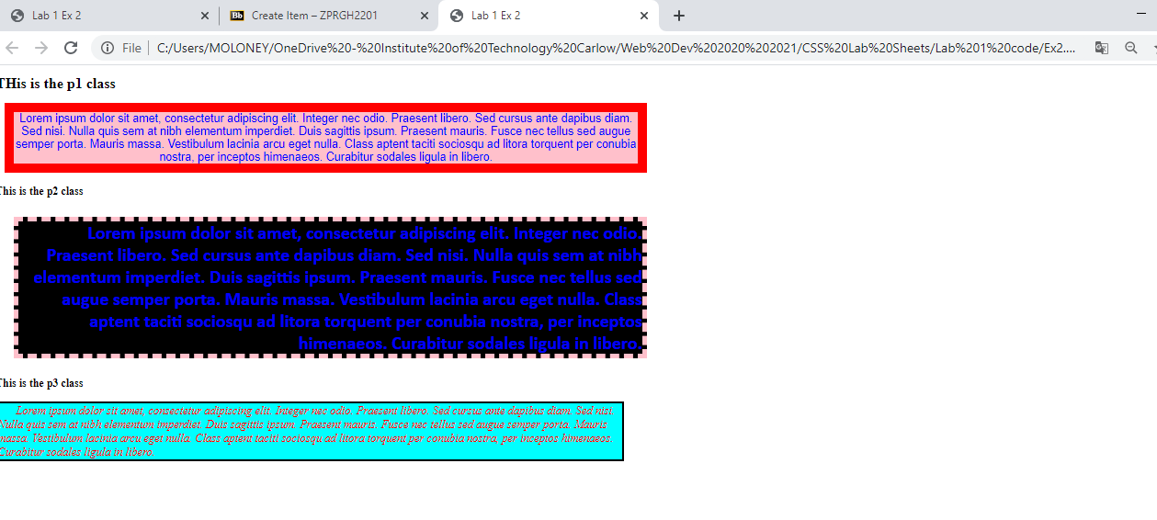

*Save your exercise files on M/WebDev/CSS Exercises/lab 1/ E2.html*

**Exercise 3**

Create six paragraphs, each with a heading.  Use h1 through h6 for the headings.  Then create a paragraph under each heading. The first and fourth paragraph must use the p1 class, the second and fifth must use p2 class, and the third and sixth must use p3 class. Classes p1, p2, p3 are from Exercise 2.

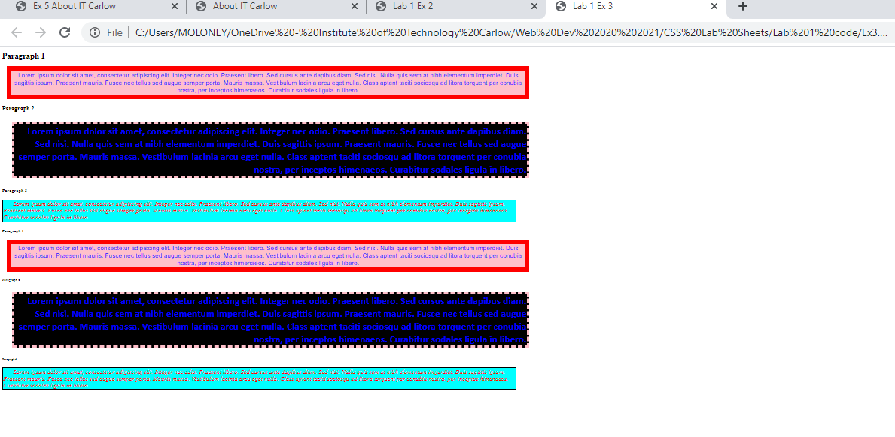

*Save your exercise files on M/WebDev/CSS Exercises/lab 1/ E3.html*

**Exercise 4**

Move the internal style sheet to an external style sheet file, and link the external style sheet file to your document.

You should see the same result as the previous exercise.

*Save your exercise files on M/WebDev/CSS Exercises/lab 1/ E4.html, and E4.css*

**Exercise 5**

Create a new .html file containing the following code:

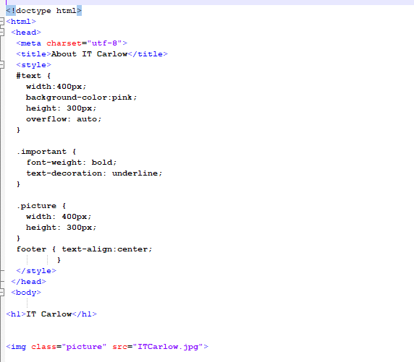

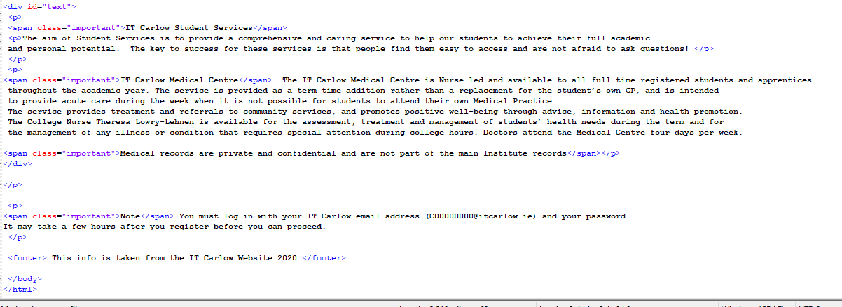

Add your comments to the code.

*Save your exercise files on M/WebDev/CSS Exercises/lab 1/ E5.html*

When you run it in Chrome you should get the following:

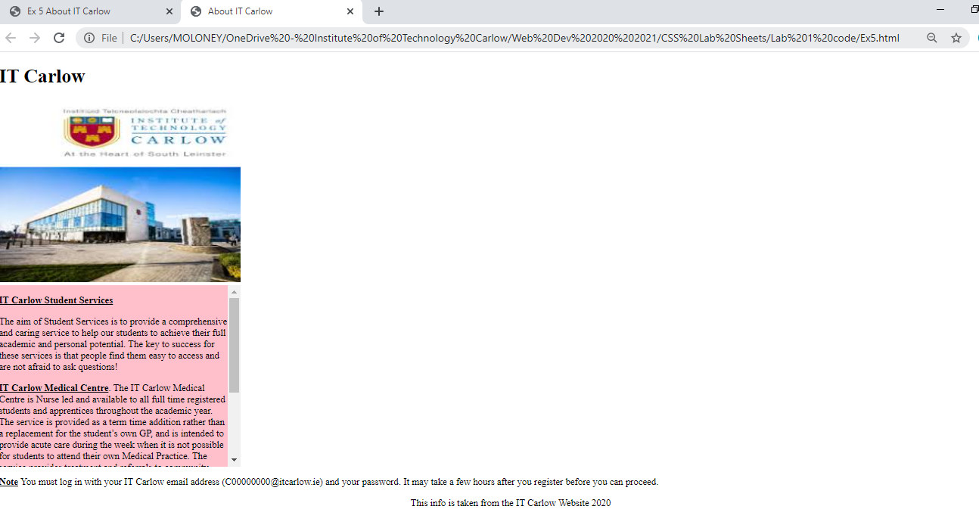

**Exercise 6**

Copy the previous exercise and save it as  *M/WebDev/CSS Exercises/lab 1/ E6.html.*

Then make the changes necessary to create a webpage that looks like the following:

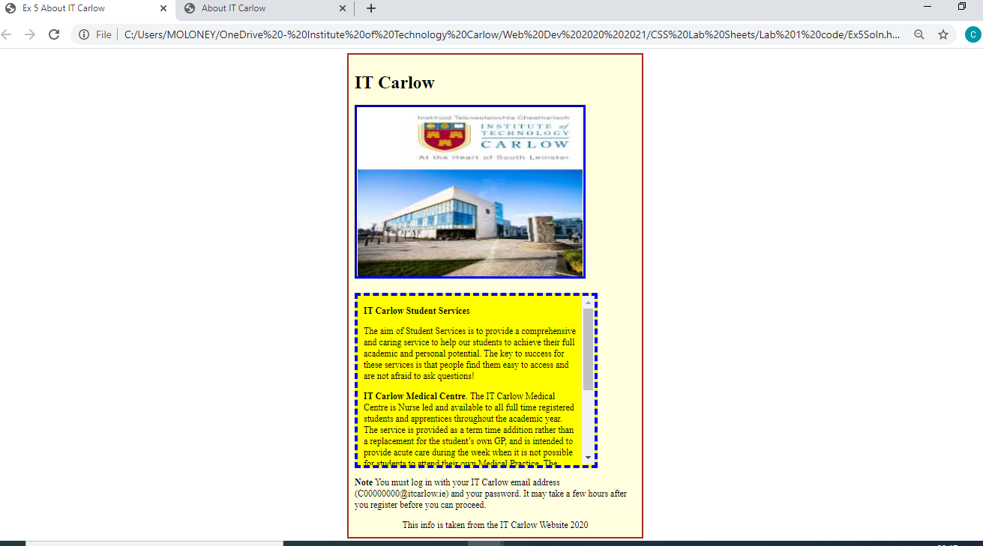

* Add the appropriate margin, border and padding to the *text* div
* Add the appropriate border to the image
* Create a div for all of the page contents and centre that in the middle of the page..
* Add the appropriate border and padding to that div.
* Ensure that whatever the padding and borders for the image and text, the width of the element will not exceed its stated width of 400px.